SEER*Educate Training Module Releases
Winter 2023 Update
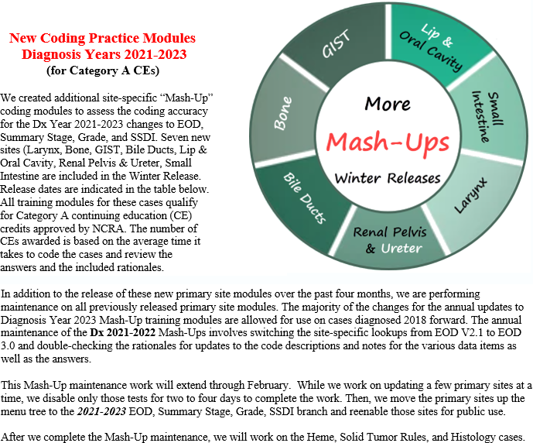
The number of free Category A CEs awarded for each training module completed is indicated in the table below. There is a total of 16 Category A CEs available in this release. The Program Recognition number to use when preparing your biannual CE submission is also provided to facilitate completing the NCRA documentation required to maintain your CTR credential.
NCRA Program Recognition # | Program Title  Dx 2022-2023  EOD, Summary Stage, Grade, SSDI | Number  of  Cases | CE  Ending Date | Category A  CEs  Approved | Date Released  on SEER*Educate
2022-086 | Larynx | 5 | 12/31/2025 | 2.5 | 22-Nov
2022-083 | Bone | 5 | 12/31/2025 | 2.25 | 23-Dec
2022.084 | GIST | 5 | 12/31/2025 | 2.25 | 23-Dec
2022-085 | Bile Ducts | 5 | 12/31/2025 | 2.5 | 23-Jan
2022-087 | Lip & Oral Cavity | 5 | 12/31/2025 | 2.5 | 23-Jan
2022-088 | Renal Pelvis & Ureter | 5 | 12/31/2025 | 2.0 | 23-Jan
2022-045 | Small Intestine | 5 | 12/31/2025 | 2.0 | 23-Jan

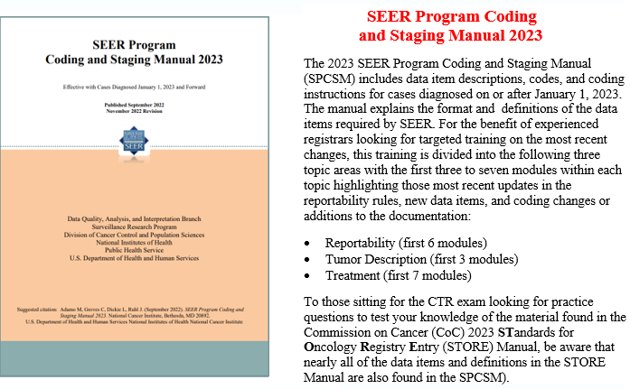
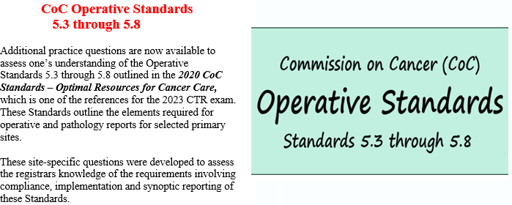
Log in or sign up at SEER*Educate today by visiting https://educate.fredhutch.org/ and Learn by Doing! These training modules are found in the following locations on this website:

- Mash-Up coding practice modules are under the Training tab, in Coding - for CEs
- SEER Program Coding and Staging Manual 2023 is under the Training tab, in CTR Prep - No CEs
- Operative Standards 5.3-5.8 is under the Training tab, in CTR Prep - No CEs under Commission on Cancer (CoC)

If you need help finding the exercises mentioned in this announcement, see the next few pages. If you have questions about accessing the exercises or printing the CE listing, please Contact Us.

SEER*Educate is funded by Surveillance, Epidemiology and End Results (SEER) of the National Cancer Institute (NCI) and the Fred Hutchinson Cancer Center. (NCI Contract Number HHSN261201800004I)

Two-page instructions for those who need help accessing the coding training modules:

More about the Mash-Ups

We created a site-specific “mash-up” coding form to facilitate assessing coding accuracy for the Dx Year 2021-2023 changes to EOD, Summary Stage, Grade, and SSDI.

There is a case scenario (the “Click here” link) and we provide the read-only coding for site, histology, and behavior to ensure that the correct data items and drop-downs are retrieved from the SEER*RSA. These are the same drop-downs vendor software will display to registrars. However, the page that displays before the coding form provides links to the various relevant manuals which you should also have open and available to complete these exercises.

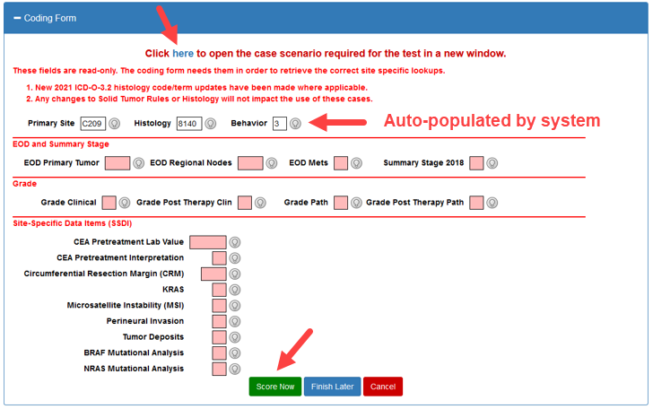

After you complete the coding form, click the Score Now button to compare your coding to the preferred answers and detailed rationales for each data item.

Quick reference on how to access new Dx Year 2021-2023 exercises and the CE report

To access the exercises, click on Training and then Coding – CEs to display the page with the test menu. Click on the + sign to expand the Dx 2021-2023 EOD line to display the sites.

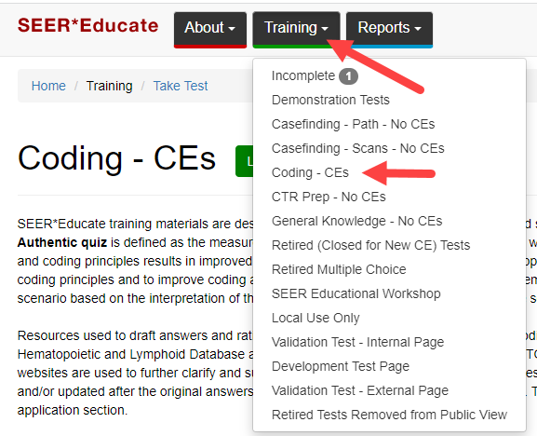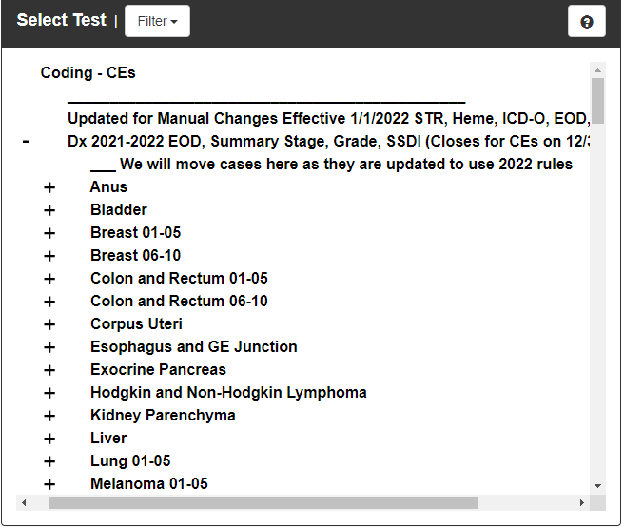

To print a report demonstrating completion of the CEs, click on Reports Menu and then View Excel Reports.

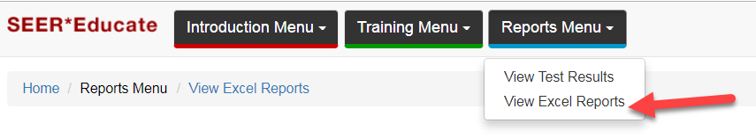
Click on the + sign to expand CE Reports section and click on Dx Year 2021-2023 EOD, Summary Stage, Grade, SSDI row. Change the start date to a date prior to when you began this material, such as 12/1/2022 and change the end date to today’s date.

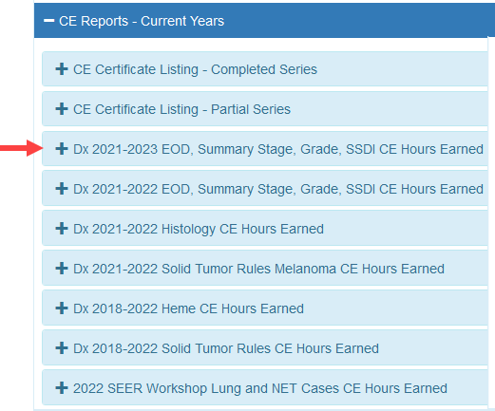

If no results are returned, you may need to retake a specific exercise where you originally scored less than 70%. We recommend waiting at least two days before retaking an exercise so that you know you are testing your knowledge of what you learned from your first attempt versus your immediate short-term recall of reading the rationale.

