NAACCR XML to SQL Load

Application Start

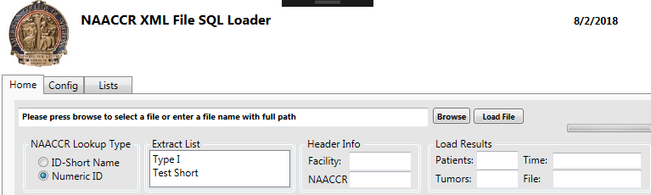

Two variables need to be set:

Naaccr Lookup Type can use either Short Name or NAACCR Number depending on file content.
Extract List: These are list header records stored in a database that have children of NAACCR fields that will be used to collect data from the file and load into the export file.

After selecting a file with the browse button the top of the file will be displayed.

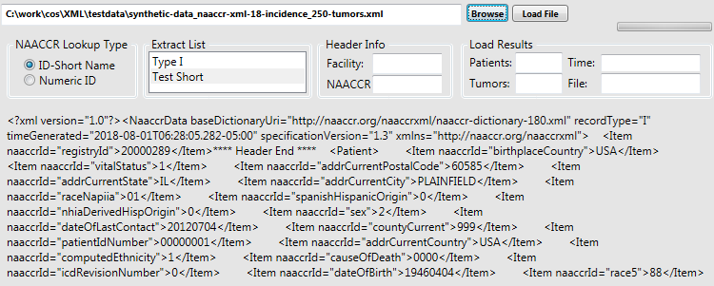

After hitting the “Load File” button the file will load showing progress with the patient and tumor counts increasing to show process status. At completion the load time and output file name will be displayed, in this case time represents 2.94 seconds for 250 records. In this case there was no NAACCR Version in the file.

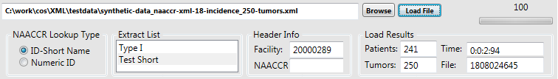

Output File
Using the KB delimiter Alt 0187 “»” and a CR LF for each tumor the file is written with the name including a datetime stamp. Patient and header information is redundantly entered for each tumor record.

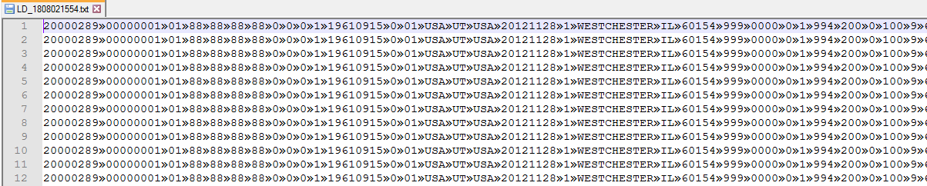

SQL DB List
Below is a sample of the list details that were used to process the file. Both SQL Server and Oracle have SQL Loader programs that would just need a corresponding control files for use in the batch running of the loader.

