2022 Annual SEER Workshop
Advanced Topics for Registry Professionals
September 20-22, 2022

The free workshop is open to all cancer registrars and will be held virtually on Tuesday-Thursday, September 20-22, 2022 from 12:00-5:00 PM EDT. (NOTE: It was moved from July 19-21, 2022.) The goal of the workshop is to expand registrars’ knowledge of several important topics including: coding for lung cancer, NET, and brain cases; data quality assessment; synoptic operative reports; and more. There will be presentations from subject matter experts including surgeons, pathologists, and oncologists.

Registration for this workshop opened on July 5th and closes on September 16th. If you have not already signed up, the workshop registration link is available through the NCRA’s website at 2022 SEER Virtual Workshop Online Registration (ncra-usa.org).

Participants are asked to complete EOD, Summary Stage, SSDI and Grade coding for the assigned lung and NET cases in SEER*Educate before the workshop in order to assist the speaker while preparing each presentation to highlight the observed challenges associated with interpreting medical transcripts, achieving coding accuracy and consistently applying rules and guidelines outlined in the manuals used to code these data items.

As of 7/11/22, nearly 1,000 had already registered for the upcoming workshop. However, less than 25% have completed coding the 10 cases. To help us identify the most problematic issues observed when coding lung and NET cases, we hope most will be able to complete these exercises by 8/1/22. Given the recording schedule for these two presentations, we will update the final data item accuracy frequencies for each field for both sites for cases completed by 8/15/22.

For more information about the coding cases, log in or sign up (it’s also free) at SEER*Educate today by visiting https://educate.fredhutch.org/, select the Training tab, and click on SEER Educational Workshop. By completing the coding of these case for the workshop, the following number of Category A CEs have been approved:

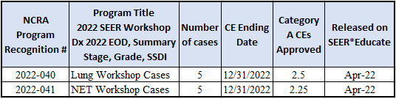

If you have questions about accessing the exercises or printing the CE listing, please Contact Us.

Learn by Doing!

The SEER*Educate Team

